**Lesson 03 Demo 05**

**Data Integrity Using GenAI**



**Objective:** Toensure the quality of the data using GenAI

**Tools required:** Julius AI

**Prerequisites:** None

**Steps to be followed:**

1. Download the dataset
2. Upload the dataset to Julius AI
3. Check the data integrity using a prompt

**Step 1: Download the Dataset**

* 1. Download the Customer.csv from the LMS under the **Reference Materials** section

**Step 2: Upload the dataset to Julius AI**

* 1. Navigate to [Julius AI](https://julius.ai/)
  2. Click on Start a chat on the homepage

* 1. Click on **Add a file**… to upload the dataset

**Step 3: Check the data integrity using a prompt**

* 1. Create a prompt to ensure data integrity on the sample dataset uploaded to Julius AI

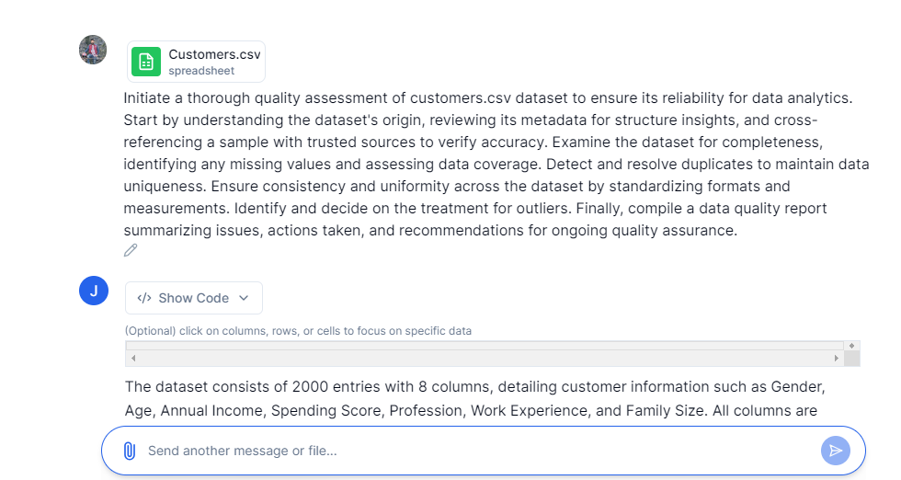

3.2 Check for data consistency, duplicates, and anomalies and identify missing values

* 1. Check the accuracy of the data

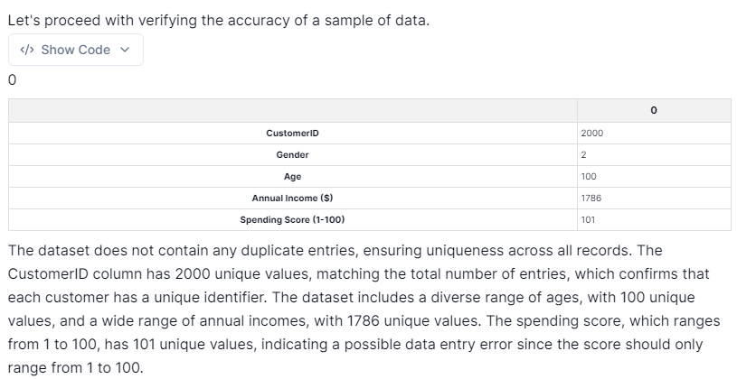

3.4 Standardize formats and measurements for consistency and assess the dataset for outliers

* 1. Create a quality report summarizing the findings and recommendations based on the analysis conducted

